Circle of Friends Circle of Friends Circle of Friends



Circle of Friends

Jane Turner
Chartered Educational Psychologist
 Educational Psychology Service
special educational services

Foreword

This booklet is a revision of a booklet first published in 1999 in response to enquiries resulting from Social Inclusion: Pupil Support, Circular 10/99. This DfEE guidance recognised Circle of Friends as an example of good practice to promote social inclusion and prevent exclusions. Buckinghamshire Educational Psychology Service has been at the forefront of research and development in using Circle of Friends although the intervention originated in Canada and is now used in many Local Authorities across England and Wales.

This booklet aims to provide background information and practical guidance in how to set up and run a Circle of Friends with useful resources for schools to help them implement the process.

Assistant Educational Psychologists working in Buckinghamshire in 2001/2 collated information about resources for the follow up groups. We wish to acknowledge contribution not only to this booklet but also to the ongoing evaluative research on Circle of Friends.

Acknowledgements

Anthony Atwell Assistant Educational Psychologist 2001/2 Bucks
Lisa Harrison Assistant Educational Psychologist 2001/2 Bucks
Louise Stevenson Assistant Educational Psychologist 2001/2 Bucks
Rebecca Welch Assistant Educational Psychologist 2001/2 Bucks

Norah Frederickson Senior Educational Psychologist (CPD)
Programme Director, University College London

Laura Warren Educational Psychologist

Jane Turner
Senior Educational Psychologist (Inclusion)
September 2002

CONTENTS | Page Number
Background | 1
Introduction | 2
Psychological underpinnings | 3
Circle of Friends Intervention | 5
Questions answered | 6
Practical Steps to Setting up a Circle of Friends | 7
Preparations | 8
Importance of friends | 10
Problem solving | 11
Summary | 13
Circle of Friends Sessions | 14
The first meeting | 15
Topics for weekly sessions | 15
Ending the circle | 16
Small Group Activities | 17
Ice breakers | 18
Developing Friendships | 21
Teasing / name calling | 22
How to say ‘No’ (assertiveness skills) | 24
Dealing with anger | 25
Keeps calling out | 26
Keeps flicking things and fiddling | 27
Won’t listen | 28
Use of inappropriate language | 29
Lying, cheating, stealing | 30
Doesn’t respect adults | 31
Arriving at school, breaktime, lunchtime | 32
Being on time | 33
Staying in school | 34
Having the correct equipment | 35
Doing homework | 36
Independent study skills | 37
Classroom responsibilities | 39
Independent personal organisational skills | 40
Appendices | 41
People in our lives | 1
Certificate | 2
Group name and rules | 3
Weekly Review Meeting Record | 4
Information for Parents | 5
Standard Letters To parents (class) | 6
To parents (group) | 7
To parents (thanks) | 8
Research and Evidence Base | I
Buckinghamshire Pilot project for greater inclusion of children with special | II
educational needs (Standards Fund 18b) - Research paper (unpublished)
Norah Frederickson and Jane Turner
References and Further Reading | IX
Useful websites | X
Books to use with children | X

Circle of Friends
Peer Support for Social Inclusion

Background

The ‘Circle of Friends’ approach originated in Canada. (Pearpoint J., Forest M., Snow J. (1992) The Inclusion Papers. Toronto Inclusion Press). The author's stong belief is that the need to belong, to be welcomed and accepted in all people regardless of disability or diversity is central to the development of a more tolerant and creative society. Acceptance and belonging in the community and having friends who support each other is a central tenet of their approach.

International pressures arising from the Human Rights movement, the United Nations Convention on the Rights of the Child followed by the UNESCO Statement at Salamanca are key international drivers towards the increased inclusion of all children in non-segregated educational provision.

Nationally, inclusion and inclusive practice are identified Government priorities. Reducing the increasing numbers of children and young people permanently excluded from schools and raising attainment for all learners are constant themes in guidance and legislation. (viz. Excellence for All (1997), Social Inclusion: Pupil Support, Circulars 10/99 and 11/99 from the Social Exclusion Unit, National Curriculum 2000 Inclusion Statement, Inclusive Schooling (2001) SEN Code of Practice (2001), the Ofsted Framework for Educational Inclusion, the McPherson Report, Steven Lawrence Enquiry and the Disability Code of Practice (2002). This leads the way to the greater acceptance and inclusion of individuals with diverse needs in the mainstream of education wherever possible.

Schools and teachers face increasing challenges to find ways to adapt teaching and learning styles to accommodate diverse learning needs. The Index for Inclusion commissioned by the Centre for Studies on Inclusive Education (CSIE) and distributed to all schools in 1999, promotes a the social model of barriers to learning and participation, in contrast with the more traditional thinking which unhelpfully attributes problems to deficits within children.

Research has confirmed that directing attention to the context in which children learn and, in particular, promoting change in the child’s social environment can bring about significant improvements in individual learning and development.
Introduction

Circle of Friends is one strategy or tool that has been widely used to promote social inclusion. It is recommended in Social Inclusion: Pupil Support, Circular 10/99 as an example of best practice along with Circle Time and Peer Mediation. It is particularly used in schools to promote the inclusion of individuals who face exclusion, rejection and isolation from their peers because of their disability, behaviour or some other individual difference.

Teachers have been looking for effective ways of promoting social acceptance and ‘Circle of Friends’ is gaining increasing recognition across the UK. There is now widespread support for this approach from Educational Psychologists and behaviour support specialists.

Circle of Friends is an inclusive approach to support children experiencing emotional, behavioural or social difficulties in the educational setting by enlisting the help of a peer group drawn from the whole class which is established as a special group/circle of friends. This group helps to set, monitor and review weekly targets in a meeting facilitated by an adult.

Circle of Friends, as a time limited intervention, is appropriate for children in Key Stage 2 and older. It has been used to support children during secondary transfer or moving into a new school context. For younger children and older young people, it may need some adaptation and modification. This approach has also been used to support children with social communication difficulties and with mild autistic spectrum needs, who experience friendship and interaction difficulties as well as children with more significant disabilities, who may need a longer-term circle.

This booklet contains practical advice on setting up and running a Circle of Friends. Standard letters, certificates and recording proforma for the weekly review meeting can be adapted and customised to meet school’s needs. A further set of suggested activities for follow-up sessions with the small group has been developed by a group of Assistant Educational Psychologists in Buckinghamshire, who have also been undertaking ongoing evaluative research.

Psychological Underpinnings

The approach draws upon a number of psychological theories: Social Learning Theory, Maslow’s Hierarchy of Needs, Humanistic Psychology (Rogers), Personal Construct Psychology (Kelly) Dodge’s model of Social Interaction, attribution theory and group relations theories to name but a few.

Social Learning Theory
Social Learning Theory emphasises the importance of environmental influences on learning and behaviour. Changing environmental factors may affect both learning and/or behaviour. Circle of Friends harnesses the positive influence of peers and group dynamics. The friends may contribute to improvements in the classroom and playground experiences of the child.

Hierachy of Needs
Maslow discussed the importance of the need to belong in promoting self-esteem. This is a pre-requisite for learning. Self-confidence and self-assurance help us all to learn from unsuccessful attempts to master a skill and to keep on trying. Circle of Friends is used to build confidence and self-esteem by positive reinforcement and acceptance by peers. The group provides a safe climate to share fears and worries and is a reference group in which the child or young person with difficulties can explore and rehearse new ways of behaving.

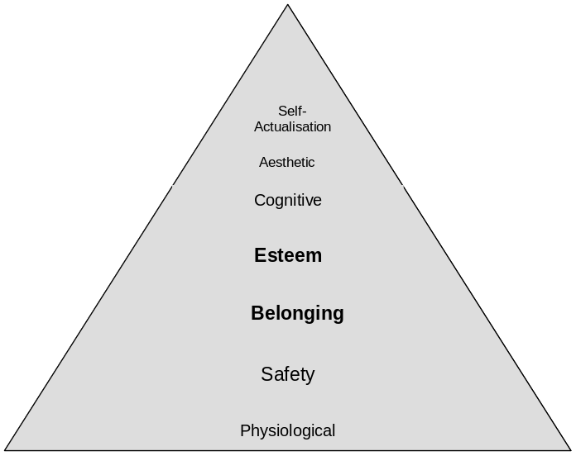

Figure 1. Maslow’s Hierarchy of Needs

Humanistic Psychology
Roger’s theory of self emphasises the importance of congruence between self-perception, the perceptions of others and one’s ideal self. Incongruence may lead to anxiety and fear resulting in negative behaviours and attitudes. The importance of being valued and having someone to offer unconditional positive regard are essential to a person’s well-being. Circle of Friends creates an opportunity where difficulties can be openly discussed and solutions to problems sought. It can reaffirm the value of all and in particular the child who may be experiencing difficulties.

Social Interaction
Dodge’s model of social interaction shows that social behaviour is influenced not only by the social situation and the child’s perception and understanding but also by the perceptions, understanding and judgements of other children and the influence of their behaviour. Circle of Friends permits discussion of how others perceive and judge behaviour. It provides role models and offers opportunities to practise alternative ways of behaving.

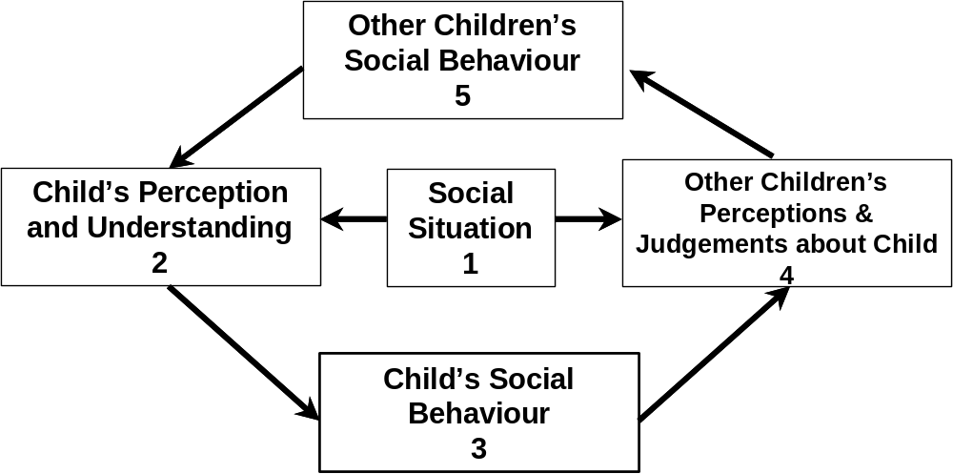

Figure 2. A model of Social Interaction, Adapted from Dodge et al (1986)

Circle of Friends Intervention
Circle of Friends Circle of Friends Circle of Friends

What is the Circle of Friends intervention?

Circle of Friends is an inclusive approach to support children experiencing emotional, behavioural or social difficulties in school by enlisting the help of the peer group of the whole class and setting up a special group/circle of friends. This special group helps to set, monitor and review weekly targets facilitated by an adult.

What are the objectives?

To improve social skills, confidence, self esteem

To access peer support for a target child / young person

To reduce inappropriate behaviour

To encourage understanding of relationships at a range of levels

What are the key benefits?

Enlists peer support and empathy for an individual

An inclusive approach - can be used for a wide range of difficulties and presenting behaviours

Improves self esteem and confidence of the target child and others

Brings problems into the open and allows discussion making it an effective
anti-bullying strategy

Contributes to the social and personal development and citizenship curriculum

Supports the class teacher, group tutor

School-based intervention
- Minimal resource implications – mainly time and a quiet place for 30 minutes a week

What is needed in school?

Desire to change or to make a difference for a child or young person experiencing difficulties, rejection, isolation or at risk of exclusion
- Commitment to follow up - needs 20 - 30 minutes per week for the small group/inner circle plus an agreed adult (Class teacher, group tutor, Headteacher, SENCo or support teacher)

Agreement of all parties – child/young person, parents/carers, class teacher/ group tutor, SENCo, headteacher

School needs to decide on how inner circle of friends is composed

School needs to decide on how to inform other parents and to gain informed consent.

Informed consent is very important. Some standard letters can be found in the Appendices.

Practical Steps to setting up a Circle of Friends

Circle of Friends Circle of Friends Circle of Friends

Preparation and commitment are crucial to the success of the intervention/strategy

How to set up a circle

(This could be facilitated by an Educational Psychologist, Behaviour Support Teacher, Group Tutor, Year Head, Senco. The Class Teacher and the adult who will be facilitating the weekly review sessions should attend. Practice suggests that an external facilitator is preferable)

Whole Class Session
40 – 60 minutes should be allowed for this part of the intervention.

Whole class session, target child not usually present, run by someone trained in the intervention. The target child should be happy with this arrangement and found an alternative constructive activity

Class sit on chairs in a circle with class teacher, EP and other adults as appropriate

Someone to scribe/keep notes/write posters

Objectives explained

Warm up/ ice breaker activities to set the scene

How to start the session

It is important to set the scene and create a safe, trusting and relaxed atmosphere.

Ice breaker games are helpful:-

to introduce the idea of something special

to create group identity

to enhance listening skills

to reinforce ground rules

to have fun

Suggested ice breaker and warm up activities

Pass the smile

Sentence completion e.g. “ My favourite colour/food is............” followed by a game to mix the group

Fruit salad - each child told name of fruit, they then change seats when fruit is called out - all change for “fruit salad”

Paint pot - similar to above using colours

Setting the scene by explaining the
objectives

why we are here?

to ask for help from children / peer group

to help focus child / young person

not usual to talk about someone not present explanation of this as appropriate

everyone has agreed - child, school, parents

What are the ground rules?

The ground rules are similar to those of Circle Time and classes may be familiar with this way of working. A reminder is always helpful.

- Confidentiality - explain using appropriate language to age group, private, include feeling safe to say/share/express ideas, to avoid gossip/rumours

One person speaks at a time

Listen to each other - no interruptions

Others that may be helpful to the group e.g. no ‘put downs’

Creating a picture of the focus child or young person

What does the focus child do, which is good, helpful, in class and in the playground? It is extremely rare that a class will find nothing positive to say about a child in the experience of practitioners using this approach. If this is considered likely to happen then this might be detrimental to the child and different intervention would be more appropriate. It is important to feedback positive comments to the focus child and to celebrate them.

What does focus child do, which is not so good, or helpful in the class or the playground? What might he or she find difficult about school? Hearing the difficulties the class is experiencing can be revealing to the teacher. Listening, acknowledging and being open about the issues can be very helpful for the class.

All comments are listed so that the class can see. The lists can be used to help feedback to the child and to identify specific targets. Writing down what the children say on a flip chart is important as it confirms the importance of what they are saying.

The friends in our lives

This part of the procedure is to enlist the empathy and support of the whole class. Sometimes this is done as a pencil and paper exercise.

We can think of the people in our lives in four circles: -

our family and people at home – central circle, our anchors, circle of intimacy

our best friend and other members of the family – friends, our allies, circle of friendship

people we see everyday and do things with – friends, circle of participation

people who are paid to look after us – peripheral, circle of exchange

See Appendix 1. Some practitioners choose to do this as a paper and pencil exercise and give all the pupils a set of concentric circles with “ME” in the centre to fill in for themselves. Practitioners in Canada found that people with significant disability are less likely to have many people in the friendship and participation circles and more professionals in the circle of exchange.

The importance of friends

The next few questions are to gain empathy from the class and raise the awareness of the importance of friends in our lives.

How would you feel if the only people in your life were the people at home and people paid to look after you, that is family and teachers or other adults in school?

How would you feel if you had no friends?
- How would you feel about going to a new school where you don’t know anyone?

What might you think?

Record all comments. Depending on the age group of the class, a wide range of negative feelings will be listed including loneliness, confusion, anger, boredom etc.

How feelings and thoughts affect behaviour
(The psychology lesson)
The next few questions draw attention to the way in which feelings affect behavioural outcomes, a key area for psychologists. Older pupils might also be encouraged to say how feelings might affect their thoughts as well.

The way we feel or think affects what we do

What might you do if you felt like that?

what else?

at home?

at school?

in class?

in the playground?

Behaviour

Thoughts Feelings

Record all comments. A wide range of behaviours may be listed depending on the class but may include attention seeking, making people notice, kicking and shoving or other acting out, withdrawing/keeping out of the way, crying, running away, telling an adult. If necessary, point out the similarities between this list and the list of things the class generated earlier in the session that the focus pupil does, which are not so helpful or difficult.

Hypothesis to help improve positive behaviour

Research tells us that happy, confident people learn better than people who are sad and feel bad about themselves.

If we can help x to feel happy and welcome and that he or she has friends / support in our school / class then he or she might behave better and will learn better.

Getting the group to problem-solve

The next questions are to help the class to find some solutions and to enlist helpful strategies for the focus pupil.

How are you going to make x feel happy and welcome and that he or she has friends in his or her new school?

How do we show friendship?

How can you, the class show that you are friendly?

How can you help the focus child?

Ask the class if they would do some of these things

Record all suggestions and ask the class if they could do some of these things. It is more likely that a suggestion will be followed through if each pupil is encouraged to think of one small thing s/he could do. A class round of “I can help by………..” could be useful.

Selecting the Circle of Friends

This part of the procedure is to identify the Circle of Friends within the class / whole group setting. There is a range of ways in which this can be done. Older pupils may wish to think about the commitment and volunteer privately by completing a paper slip rather than by a show of hands. Sometimes it might be helpful for volunteers to give a reason. There may be some pupils whose parents have expressed hostility towards the focus child’s involvement with their own child. Some pupils may be good role models and others not so good. The class teacher/group tutor has a key role to play in the group selection, as their knowledge about the pupils is greater than that of the facilitator. Once committed, it is important that the group is consistent and changes are minimal.

A small group 6 – 8 pupils to be a special set of friends for target child

Ask for volunteers – some people give slips of paper for volunteers to say Yes/No

Class teacher / group tutor selects

Mixed sex, usually best

At least one good role model

Others who might benefit from extra adult attention

Pupils who have shown some insight during the session

Ending the whole class session

The session takes between 40 and 60 minutes to complete. It will be important to discuss this with the school as part of the preparations. It is an exciting and emotionally heightened session and the class deserve to have a break afterwards.

Thank all the class for their contributions, ideas, thinking, following the rules

Ask small group to spend a few extra minutes after the session with the focus child to feedback and decide what to do next

Encourage all the class to try to do one friendly thing each week

Finish with pass the smile or similar game to end on a positive and cohesive note.

This is the end of the whole group session. It seems to be important not to rush, to listen and accept all suggestions. The group needs then to have a short break before moving on to another lesson.

The selected group then meet together with the focus pupil for a feedback session with the adult who will be facilitating the follow up meetings. Ideally, the first meeting of the group should take place as soon after the whole class session as practicable.

Evaluation - did it make a difference?

The growing importance of evidence-based intervention means that evaluation is an essential part of any intervention process in order to learn how to improve the way we work. Various evaluation measures have been used in research studies. A Social Inclusion Survey* before and after the intervention would give a picture of the social relationships within a class. My Class Inventory* could give a picture of pupil’s perceptions of the levels of friction, cohesion, competition and difficulty experienced by the class. Comparison could be made using observations of the pupil’s behaviour before and after the intervention. Questionnaires or interviews with the child, parents and/or school staff may be helpful. Attainment scores might also reveal differences. An educational psychologist can advise on the most pertinent evaluation measures on an individual case basis.

* Psychology in Education Portfolio Eds Frederickson N. and Cameron R.J

Summary

Warm up
- Pass the smile.
- Sentence completion – “My favourite colour is ……..”
- Play paint box.

Setting the scene
- Introduction 1. Self and job title - Educational Psychologist.
2. Explain role - we work with many schools to help children.
3. Explain that adults in the school think that the children in the class can help someone.
- Not usual to talk about someone who is absent.
- Everyone has agreed - child, school, parents.

Ground Rules
- Confidentiality.
- Listen.
- Only one person to speak at a time.
- No put-downs.

Key Questions
- What does the focus child do that is good / helpful in the class / playground?
- What does focus child do that is not so good / helpful in the class / playground?

Friends
- Think of people in each circle 1. Family / people at home.
2. Best friends / other family members.
3. People we see everyday and do things with.
4. People paid to look after us.
- How would you feel if circles 2 and 3 were empty?
- How would you feel if you had no friends?
- What might you think?
Psychology lesson
- The way we feel / think affects our behaviour.
- If you had no friends what would you do at home? at school? in class? in the playground?

Hypothesis (Maybe if we show friendship then difficult behaviour might improve)

How do we show friendship
- How can you help the focus child?
- “I” statements.

Choosing the circle of friends
- Thank everyone.
- Ask the small group to go with you to meet focus child at the very end of the session.
- Encourage everyone to one friendly thing each week.
- Play pass the squeeze.

Circle of Friends Sessions

Circle of Friends Circle of Friends Circle of Friends

The first circle meeting

Ideally, this should take place soon after the whole class session and should be fairly short (15 – 20 minutes). The focus child will not have been part of the whole class session and may have been anxious about what was being said in his or her absence. It is important to reassure the focus pupil and to check out that the volunteers are OK for him or her and that they are all quite happy with their decision to help.
- The group chooses a name for the group (not including child’s name). Some examples are ‘The Solvers’, ‘The Happy Helpers’ and ‘The Funky Friends’

Feedback briefly to focus child about session with emphasis on the positive

Reminder about ground rules, confidentiality
- Set boundaries – the group is there to help and support and are not responsible for unacceptable behaviour against school rules, if they are concerned in any way an adult should be consulted

Set targets for the week

Set a time, place for the review meeting.

Weekly circle review meeting

The weekly meeting should keep a record of activities and strategies and the successes. The meetings need to be seen as an important part of the curriculum and should be cancelled only for reasons acceptable to the group. The meetings will need a minimum of 30 – 40 minutes. Ideally the targets and strategies selected by the group should be shared with the class so they can all contribute to the success of the intervention.

Warm up game

What went well this week? It is essential to celebrate successful attainment of agreed targets

What did not go so well this week? Discuss and listen

Targets / strategies for next week

End session with a game

The sessions should be recorded by the adult but pupils might like to take turns

A suggested proforma for recording the weekly sessions can be found in the Appendices – see No. 4

Topics for weekly sessions

Usually and preferably, topics will come from the group and issues arising during the week. Targets can be drawn also from the list of things that the pupil finds most difficult. The resources in this booklet contain suggestions to address some of these areas – see Small Group Activities, page 17 onwards. Topics include: -
- Name-calling by other pupils
- Teasing or being picked on
- Bullying of other kinds
- Making new friends, being a good friend
- Social skills - listening to others, sharing, taking turns, waiting, playing games fairly
- Coping with feelings, recognising feelings
- Homework
- Relationships with adults, pupils, opposite sex
- Lunchtime and break time
- Appropriate use of language
- Not knowing what to do in lessons
- How to say “No” - assertiveness skills
- Being on time, having equipment etc.

It might be helpful if the group agrees to share weekly targets and strategies with the class, relevant adults in school and with parents. Some suggested activities and structure for follow-up meetings have been developed by Assistant Educational Psychologists working in Buckinghamshire and can be found starting below.

Ending the circle

- How long the circle runs will depend a lot on the focus child, the group and whether the desired targets have been met
- Most groups run for about a term, some for longer. In Buckinghamshire we have found that a difference can be made in 6 follow-up sessions. Children with significant needs may need a permanent circle. In Canada, the circle usually includes the parents
- Start and finish times seem to work best when natural school breaks occur i.e. beginnings/ends of terms and half terms
- Some groups have needed a “kick start” to keep up motivation when things become difficult (groups go through the usual forming, storming, norming performing stages, which need support from the facilitating adult)
- Pupils should be encouraged to stay in the group once it has started, but if they no longer wish to be involved, it is probably better to let them leave
- Some groups have re-formed following another whole class session especially when the pupil was unknown to the class before e.g. when reintegrating from another school or specialist provision
- It is important to have a proper ending and finish off the group by celebrating successes, thanking the class, the facilitating adult and the group and marking the occasion in some way
- Certificates of thanks to group members including adults have been appreciated. An example is provided - see Appendix 2
- A letter to thank and inform parents, if they have not been directly involved, about the end of the circle is also appreciated – see Appendix 7.

Small Group Activities

Ice breakers

Developing Friendships
Teasing/ name calling
Dealing with anger
Keeps calling out
Keeps flicking things and fiddling
Won’t listen

Use of inappropriate language
Lying, cheating, stealing
Doesn’t respect adults
Arriving at school, breaktime, lunchtime
Being on time
Staying in school
Having the correct equipment
Doing homework
Independent study skills
Classroom responsibilities
Independent personal organisational skills

Produced for Buckinghamshire Educational Psychology Service by:

A.Atwell, L. Harrison, L. Stevenson & R.Welch 2002

Appendices

Circle of Friends Circle of Friends Circle of Friends
People in our lives
People at home

Best friends
Mum, Dad
brothers and sisters
others at home
best friend
cousin
aunt
grandmother
godparent
grandfather

People we do things with
football
club
brownies
scouts
guides
class mates

church
people in
the park

People who are paid to look after us
police
fireman
lollipop
lady
dinner
supervisor
support
assistant
shopkeeper
speech therapist
physiotherapist
educational psychologist
librarian
nanny
neighbours
other children in school
parent’s friends
teachers
doctors
nurses
baby sitter


Signed _____________________
Date ___/___/___
was a member of

Certificate

This is to certify that

A Circle of

Friends

Circle of Friends Circle of Friends Circle of Friends
The name of our group is

Group Rules

1.

2.

3.

Agreed by ……………………………………….

Date …………………….
CIRCLE OF FRIENDS
Circle of Friends Circle of Friends Circle of Friends

Weekly Review Meetings Record

Name of Group: ………………………………………………………………………..

Date …………………………………. Week Number: ……………

Review of last week’s target(s):

What went well? Which strategies were most useful?

What needs more work?

Targets for next week:
Target 1
- Strategies (How will we help meet this target?)

Target 2
- Strategies (How will we help meet this target?)

Target 3
- Strategies (How will we help meet this target?)

Circle of Friends Circle of Friends Circle of Friends

Information for Parents

Circle of Friends is an intervention designed to support a particular child who is experiencing difficulties in school. Children who are isolated, have special educational needs, or are vulnerable to social exclusion can all benefit from such an approach.

Having friends and being a good friend comes naturally to most children but some find it more difficult. Having no friends or feeling isolated at school can lead to a range of difficulties in the school context.

There is a growing research evidence-base to support its effectiveness in promoting social inclusion and friendship skills. Circle of Friends has been widely used in Buckinghamshire and in other LEAs including Nottinghamshire, Essex and Sheffield. Research is ongoing.

Before deciding to use Circle of Friends there will have been full consultation with the child, his parents/carers, the class teacher and other key members of staff in the school. It may also have been discussed with the behaviour support teacher or educational psychologist, who might be involved in setting up and monitoring the progress of the Circle.

Following preparations and gaining consent from parents/carers, the individual child will not be present for the session involving his/her class and set up his/her support group (Circle of Friends). Feedback will be given to the child by the facilitator following the class session. Thereafter the child is part of the Circle.

The Circle will then meet on a weekly basis possibly with a member of school staff, the behaviour support teacher, or an assistant educational psychologist. Ideally the group will decide when it is no longer needed but practically groups tend to meet for about 6 sessions (half a term).

Parents/carers will be given the opportunity to give their consent to their child participating in this intervention, which is underpinned by psychological theory and knowledge. Parents/carers of children who wish to be part of the support circle will also be asked permission for their child’s participation.

Circle of Friends is usually very positively evaluated by children who have taken part. In part of a follow-up study, four years after a Circle of Friends intervention one pupil said, “ I wish I could have my circle back”.

Circle of Friends is widely promoted as an intervention to promote social inclusion and it is also used to combat bullying and develop social skills.
Standard letter for parents (Whole Class Session)

Head Teacher Any School
Anywhere

Date

Dear Parents/Carers
Circle of Friends Circle of Friends Circle of Friends

Circle of Friends

We are proposing to set up a Circle of Friends to help and support a pupil in your child’s class, who is experiencing difficulties in school, with the support of the Educational Psychology Service. Research evidence suggests that all pupils benefit from being part of a Circle of Friends intervention although it is set up to help one particular child.

An introductory meeting is planned for (date) that will include all members of the class. The session will take about 45 – 60 minutes. The session will address issues about relationships, problem-solving and citizenship skills and ask for volunteers to help the child experiencing difficulties to be part of a small Circle of Friends to help and support that child. The child, parents and school staff are agreed that this intervention may be helpful

The Circle of Friends will meet weekly for about 30 minutes with an adult to set targets and review progress for the next six weeks.

If you have any objections or queries, please do not hesitate to contact the school for more details.

Yours sincerely

Headteacher

Name of child School

I consent to my child participating in a Circle of Friends intervention.

Signed Date

Please return this form to school by …………………………………..

Standard letter for parents (Circle of Friends )

Head Teacher Any School
Anywhere

Date
Circle of Friends Circle of Friends Circle of Friends
Dear Parents/Carers

Circle of Friends

Your child has generously volunteered to be in the Circle of Friends to help and support another pupil who is experiencing difficulties in school. Research evidence suggests that pupils all benefit from being in a Circle of Friends group although it is set up to help one particular child. The circle will address issues about relationships, problem-solving and citizenship skills.

The circle will meet weekly for about 30 minutes with an adult to review progress for the next six weeks.

If you have any objections or queries, please do not hesitate to contact the school for more details.

Yours sincerely

Headteacher

Name of child School

I consent to my child participating in a Circle of Friends.

Signed Date

Please return this form to school by …………………………………..

Standard letter for parents (thanks)

Head Teacher Any School
Anywhere
Tel.

Date

Dear Parents/Carers
Circle of Friends Circle of Friends Circle of Friends

Circle of Friends

As you are aware, your child has been a member of a Circle of Friends set up to help support a pupil with experiencing difficulties in school. The group has been successful and will no longer meet on a regular weekly basis. Your child’s generous contribution has been much appreciated and we hope s/he has also gained from participation.

We thank you for agreeing to your child’s valuable contribution. S/he will be receiving a certificate acknowledging participation in support group, which could be included in the Record of Achievement.

With many thanks,

Yours sincerely,

Headteacher

Research and Evidence Base

Circle of Friends Circle of Friends Circle of Friends
Research and Evidence Base

Social Inclusion: Pupil Support, Circular 10/99

Alan Thompson and Ashley Howarth-Roberts from the Discipline and Attendance Branch of the Department for Education and Employment (DfEE) visited Buckinghamshire on 11/12/98. They observed a Circle of Friends being set up for a pupil in a primary school and attended a review meeting of a Circle of Friends in a secondary school. They also spoke to a number of teachers and educational psychologists who have been involved in this work.

They suggested a visit from David Moore, HMI, who is the national adviser to the DfEE on behaviour, discipline and attendance issues. David visited on 14/1/99. He saw a video of a circle being set up, made at a local combined school in 1998, and visited the Circles of Friends at a local primary and a secondary school. He talked with the pupils and staff as well as educational psychologists involved in the work.

‘Circle of Friends’ is now included alongside Assertive Discipline and Circle Time as examples of good practice in the Government Guidelines on behaviour and discipline in schools. (DfEE Circular 10/99 Social Inclusion: Pupil Support)

Buckinghamshire Pilot Project for the greater Inclusion of Pupils with Special Educational Needs ( Standards Fund18b) 1999 - 2002

Buckinghamshire Education Department was successful in a bid for additional Government funding for this project following evaluation of Circle of Friends interventions run by Buckinghamshire teachers in 1998.

Brief summary of the project

Buckinghamshire schools were invited to bid for participation in the project to promote the successful inclusion of pupils currently attending special schools into mainstream schools using Circle of Friends as a central strategy. There were three clusters of school in the project and each cluster was expected to successfully transfer six pupils.

University of London Psychology Team, led by Norah Frederickson and Sean Cameron, evaluated the project. Researchers evaluated the effectiveness of the project in attaining all its objectives and performance indicators. Following the first year the project was refocused to consider the transfer of pupils to secondary school. Circle of Friends was used to promote social inclusion and raise confidence of pupils seen to be particularly vulnerable at this transition.

The Special Educational Needs Strategy Group in Buckinghamshire has carried recommendations from the pilot project forward and ratified guidelines for all schools highlighting Circle of Friends as a useful intervention to smooth transition to secondary school.

Circle of friends: An Effective Intervention for Pupils with Emotional and Behavioural Difficulties?

Introduction

This paper provides an outline of the Circle of friends approach, explains its research basis and summarises existing research evidence on its effectiveness. It then briefly reports the positive results of a systematic evaluation study carried out by Buckinghamshire and University College London and identifies areas where further research is needed.

The Circle of friends Approach

Circle of friends is an inclusive approach to support children experiencing emotional, behavioural or social difficulties in the educational setting by enlisting the help of the other children in their class and setting up a special group, or ‘circle of friends’. The special group helps to set, monitor and review weekly targets in a meeting facilitated by an adult. The group members also provide support to facilitate the focus child’s inclusion and to help achieve agreed targets.

The Research Basis of Circle of friends

The research basis for this approach is provided by interactive models of social competence. Figure 1. shows the model developed by Dodge, a leading authority on aggression in childhood and adolescence. This model takes account of a wide range of influences on behaviour and the ways in which they interact:
- within child factors, such as ways in which the child thinks and feels as well as their skill levels;
- situational factors, such as aspects of the physical environment as well as the framework of rules and management practices adopted by adults;
- other children’s responses, which includes their perceptions and interpretations of a child’s behaviour as well as what they say and do in response.

Figure 1 A Model of Social Interaction in Children
Other Children’s Social Behaviour
5
Other Children’s Perceptions & Judgements about Child
4
Social Situation
1
(adapted from Dodge et al, 1986)

Child’s Perception and Understanding
2

Child’s Social Behaviour
3

Until recently, other children’s responses had been seriously neglected by researchers and practitioners. In the last 5 to 10 years there has been growing awareness in Britain of the powerful impact that the peer group can have. This is demonstrated by the research on bullying. Initiatives have been developed to harness the power of peers in positive ways, for example through co-operative learning and peer mentoring. Circle of friends is an intervention that involves peers in helping a child change their behaviour and, at the same time, changes the peers’ behaviour and attitude towards the child. It includes steps 4 and 5 of the Dodge model and so provides a link that is missing in many behaviour change interventions.

Research on Effectiveness

Circle of friends is a very new approach in the UK and there have been few studies so far of its effectiveness. Those that have been published to date have reported very encouraging results (Newton, Taylor & Wilson, 1996; Shotton, 1998; Taylor, 1996). They all use a case study approach and have been very useful in illustrating the approach, identifying themes and developing hypotheses. However, in order for us to be confident about recommending the approach more widely, we need to establish that the changes reported can be reliably attributed to the Circle of Friends intervention. In order to achieve this we need studies that are designed in particular controlled and systematic ways. The purpose of Buckinghamshire/UCL Research Project was to carry out a study that would address this need.

The Buckinghamshire/UCL Research Project

Jane Turner, who had been using it successfully with individual children in Buckinghamshire schools over the past two years, introduced Educational Psychologists in Buckinghamshire to the Circle of friends approach. The Educational Psychologists were asked to identify primary aged pupils with significant emotional and behavioural difficulties with whom they were working at Stage 3 of the Code of Practice. A group of 20 pupils was identified for whom parental and school consent for participation was obtained. The study consisted of two stages.

In Stage 1 the pupils were randomly allocated into two groups of 10. One group of 10 had a Circle of Friends intervention set up and run over a 6 week period by an Educational Psychologist in Training (EPiT) from University College London. The other group did not receive the Circle of friends intervention but staff at the schools involved were asked to spend 15-20 minutes per week with the focus child in a small group reading a story with a friendship theme.

In Stage 2 nine of the ten children who had not received the Circle of Friends intervention during Stage 1 had a circle set up by a Buckinghamshire Educational Psychologist and it was run over a 6 week period by a member of staff from the school involved.

Assessments were carried out before the start of Stage 1 and at the end of Stage 1 for both groups. In addition they were carried out at the end of Stage 2 for children who received the intervention during that stage. The progress made by the children who received the intervention in Stage 1 was compared to the progress of the children who had not received the intervention during this stage. The progress made by the children who received the intervention in Stage 2 was compared to their own progress during Stage 1. These two approaches for evaluating interventions each have their strengths and limitations. By using both we can increase our confidence in the reliability of the findings.

The social acceptance and inclusion of the focus children by the peer group.

(The results reported in this section are supported by appropriate statistical tests.)
This was measured by a questionnaire that asked each child in the class to rate on a five-point scale how much they liked to play with each other child in the class. The changes in average rating received are shown in Figure 2. In Stage 1 the social acceptance of the children who had received the intervention (Group 1) increased significantly, in contrast to the social acceptance of those who did not receive it (Group 2), which showed a slight decline. However this trend was reversed in Stage 2 when Group 2 received the intervention and then their acceptance also improved.

Figure 2 – Social Acceptance by Classmates

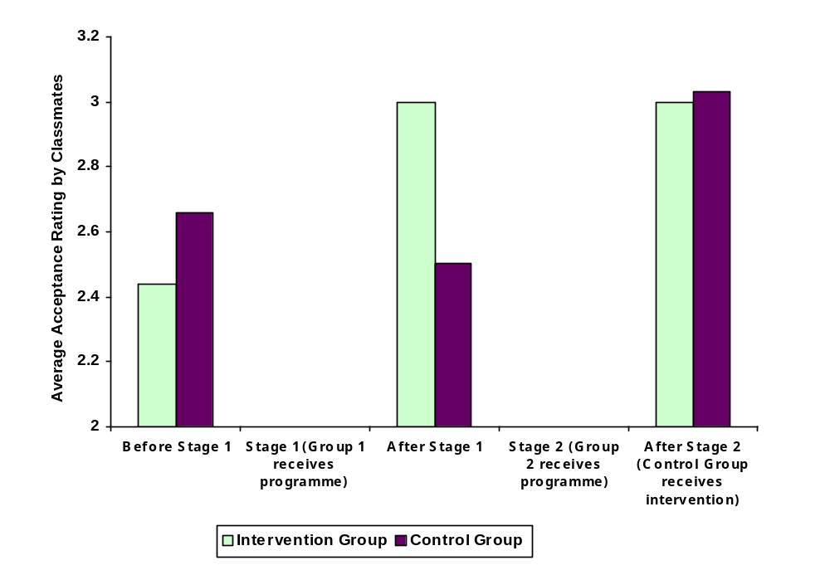

Teachers ratings of change in behaviour.

Class teachers were asked to rate the effect of the Circle of friends intervention on the child it was designed to help. Thirty-one behaviours were rated on a five-point scale from ‘much improved’ to ‘much worse’. Some behaviours focused on learning (e.g. ‘work completion’, ‘willingness to take risks in learning’) while the majority focused on social relationships and emotions (e.g. ‘relationships with peers’, ‘anger management’). Table 1 shows that the class teachers of the children in both groups considered the intervention to have had a predominately positive impact. Table 2 shows the behaviours, which were rated as improved in at least a third of the children in both groups. This suggests that the intervention impacts in particular on relationships with peers and adults, victimisation, unacceptable behaviour in the classroom and playground and distractibility.

Table 1 - Classteachers' ratings of the effect of the Circle of Friends on the child.

 | Much Improved | A bit improved | Much the Same | A bit worse | Much worse
Group 1 | 0·4% | 27·9% | 63·5% | 6·4% | 1·7%
Group 2 | 7·1% | 25·2% | 64·3% | 3·4% | 0%

Table 2 – Percentages of children rated by classteachers as improved on these behaviours as a result of the Circle of Friends intervention.

Behaviour | Group 1 | Group 2
Relationships with peers | 75% | 75%
Unacceptable behaviour in the classroom | 63% | 75%
Victimisation – being teased / picked on / isolated | 75% | 38%
Relationships with adults | 50% | 50%
Unacceptable behaviour in the playground | 50% | 38%
Distractibility | 50% | 38%

Conclusions

These findings suggest that Circle of friends interventions can produce reliable improvements in the social inclusion and behaviour of primary aged children who have significant emotional and behavioural difficulties. Similar improvements were obtained whether the intervention was implemented by educational psychologists in training or set up and monitored by educational psychologists and run by school staff. This suggests that the approach may be implemented in a very cost-effective manner.

References

Dodge, K.A., Pettit, C.S., McClasky C.J. & Brown, M.M. (1986) Social competence in children. Society for Research in Child Development Monograph, No. 213.
Newton, C., Taylor, G., Wilson, D. (1996) Circles of friends. An inclusive approach to meeting emotional and behavioural difficulties. Educational Psychology in Practice, 11, (4), 41-48.
Shotton, G. (1998) A circle of friends approach with socially neglected children. Educational Psychology in Practice, 14, (1), 22-25.
Taylor, G. (1996) Creating a circle of friends: A case study. In H. Cowie & S. Sharp (Eds.) Peer Counselling in School. London: David Fulton.

Norah Frederickson & Jane Turner, December 1998.

Over the past two years Circle of Friends has been used increasingly in Buckinghamshire schools. Anecdotal evidence indicated a range of positive changes in behaviour and self esteem for the target child, the group and class, improvements in the social climate of the classroom as well as changes in teacher attitude. Case study information has been collated (Newton, Taylor and Wilson, 1996) and modifications made to support socially neglected children (Shotten, 1998).

Little systematic research evidence is available although a number of educational psychologists are using the approach across the country. A small research project involving a group of educational psychologists in training (EPiTs) at UCL, London was agreed and the research undertaken during the 1998 spring term.

The overall aim of this project was to evaluate the effectiveness of the Circle of Friends approach and attempt to answer the questions:

- does the Circle of Friends approach result in positive changes in behaviour (as perceived by the teacher, child and other children) over and above that achieved by usual strategies employed by the school?
- what range of effective strategies is already being used in schools?
- what other outcomes result from the ‘circle of friends’ for the focus child, other children, class teacher, school?
- what other factors are important in setting up and running ‘circle of friends’?

For this project 20 children known to Buckinghamshire educational psychology service were selected. 10 children were selected to have ‘circle of friends’ by the EPiTs and 10 formed a control group. The two groups were matched for age. The following rating scales and measures were administered: -

Harter’s Self Perception Scale (self perception of focus child)

Harter’s Teacher Rating scale (behaviour ratings and attributions made by teacher about the focus child)

Asher’s Rating scale (social acceptance and inclusion of focus child within the class)

My class Inventory (socio-emotional climate and culture of the classroom)

Circle of Friends Questionnaire

After setting up the circles, the EPiTs monitored the 10 groups for 5 weekly sessions before again administering the rating scales and measures as well as a questionnaire designed to gain a qualitative evaluation of the intervention.

A follow-up project, to set up and evaluate circles for the original control group of 10 children, took place during the Summer Term 1998. Buckinghamshire educational psychologists set up these ‘circles’ and school staff monitored the weekly group review meetings. The same evaluation measures were administered after five weeks to identify any differences.

The children in the original project have been followed-up in summer 1999 to see whether progress has been sustained. The results are to be published soon in Special Education (in press).

2002 ongoing research
With the help of Assistant Educational Psychologists in Buckinghamshire further work is being done to find out how to sustain the effects of the intervention. A study completed by an Educational Psychologist in Training at UCL and now employed in Buckinghamshire noted that the impact of the whole class session waned over time whereas the Circle of Friends group sustained their modified perceptions of the target pupil. A study has been set up to monitor the perceptions of pupils, some of whom have met as a small group and some as a whole class. So far, numbers are small and this study will continue into 2003.

References and Further Reading

Bliss T., Robinson G., Maines B., (1995) “Developing Circle Time” Lucky Duck Publishing.

Bliss T., Tetley J., (1996) “Circle Time”, Lucky Duck Publishing

Cowie, H and Sharp S, (1996) “Peer Counselling in Schools”. Fulton.

Cowie, H and Wallace, P. (2001) “Peer Support in Action. From bystanding to standing by” SAGE Publications.

Curry, M. and Broomfield, C. (1998) “Circle Time” NASEN publications

Dodge, K.A., Pettit, C.S., McClasky C.J. & Brown, M.M. (1986) Social competence in children. Society for Research in Child Development Monograph, No. 213.

Frederickson N. and Cameron R.J., Editors (1999) “Psychology in Education Portfolio” NFER-NELSON

Frederickson N. and Turner J. (in press) “Utilizing the Classroom Peer Group to Address Children’s Social Needs. An Evaluation of the ‘Circle of Friends’ intervention Approach.” Journal of Special Education.

Lown J., ( 2001) “Circle of Friends Promoting Social Inclusion” Positive Behaviour Management.

Maines, B and Robinson, G. (1999) “All for Alex” Lucky Duck Publishing

Mosley J., (1996) “Quality Circle Time”, LDA

Mosley, J., and Tew M. (1997) “Quality Circle Time in the Secondary School” David Fulton

Newton C. and Wilson D. (1999) “Circles of Friends ; Peer support and Inclusion” Folens Ltd.

Newton C., Taylor G., and Wilson D., (1996), “Circles of Friends”, Educational Psychology in Practice 11, (4), 41 - 48

Pearpoint J., Forest M., and Snow J., (1992) The Inclusion Papers. Toronto: Inclusion Press

Roffey S., O’Reirdan T. (1997) “Infant Behaviour : Needs, Perspectives and Strategies”, Resources for Teachers, David Fulton.

Roffey S., Tarrant T., Majors K., (1994) “Young Friends”, Cassel

Rogers B., (1994) “Behaviour Recovery”, Longman

Shotton, G. (1998) A circle of friends approach with socially neglected children. Educational Psychology in Practice, 14, (1), 22-25.

Taylor, G. (1996) Creating a circle of friends: A case study. In H. Cowie & S. Sharp (Eds.) Peer Counselling in School. London: David Fulton.

Wilson D., and Newton C. (1996) “A Circle of Friends”, Special Children,
January 1996, 7-9

Useful Websites

www.primaryresources.co.uk, Kevin Kerr, Burghclere Primary School

www.diseed.org.uk Disability Equality in Education

http://inclusion.uwe.ac.uk Centre for Studies in Inclusive Education (CSIE)

www.parentsforinclusion.org Parents for Inclusion

www.inclusive-solutions.com Inclusive Solutions

www.allfie.org.uk Allaince for Inclusive Education

http://inclusion.ngfl.gov.uk DfES Inclusion website

http://inclusion.com Inclusion Press website

Books to use with children

Aliki (1990) “Manners”, Methuen Children’s Books Ltd.

Aliki (1989) “Feelings”, Pan Books Ltd.

Aliki (1993) “Communication”, Methuen Children’s Books Ltd.

Ruel Norman, (1989) “Me, I’m myself”, Sharp-Eye Anthology, Ginn and Company

McBratney S., Smith L., (1989) “Smile Clare”, “The Silly Table”, Sharp-Eye Story Book, Ginn and Company Ltd.

Waddell M., and Rosato A., (1989) Gluggy Books, Sharp-Eye Story Book, Ginn and Company Ltd.
Circle of Friends
Jane Turner
Chartered Educational Psychologist
Special Educational Services
Buckinghamshire County Council

Further copies of this book are available using this form and enclosing a cheque.

Price £5.00 inc p&p UK
.....................................................................................................

To: Educational Psychology Service Publications Section
Educational Psychology Service
County Hall
Walton Street
Aylesbury
Bucks HP20 1UZ tel: 01296 383219

Please send me:

........ copies of “Circle of Friends”

@ £5.00 per copy

Total = ...............................

I enclose a cheque for £ payable to “University College London (CK95)”

Name: ........................................................................................

Address: ........................................................................................

........................................................................................

........................................................................................

